PROGRAMACION ORIENTADA A OBJETOS

Manual de programador  
Move In City

Semestre 2016-2017/II

**Berrones** **Lopez Eduardo Miguel**

Objetivo del proyecto: Aplicar los conocimientos adquiridos en la clase de programación orientada a objetos

Descripción del proyecto: el proyecto es un juego en el que un ciclista tiene que esquivar varios obstáculos, el jugador tiene 3 vidas, si choca contra alguno de los obstáculos, perderá una vida, cada que supere un obstáculo obtendrá 10 puntos

**DESCRIPCION** **E IMAGEN**

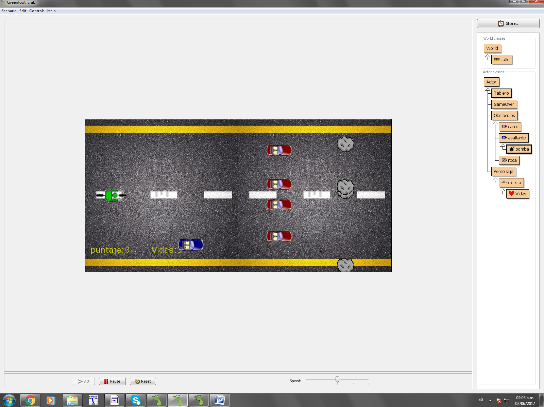

**Diagrama de clases UML**

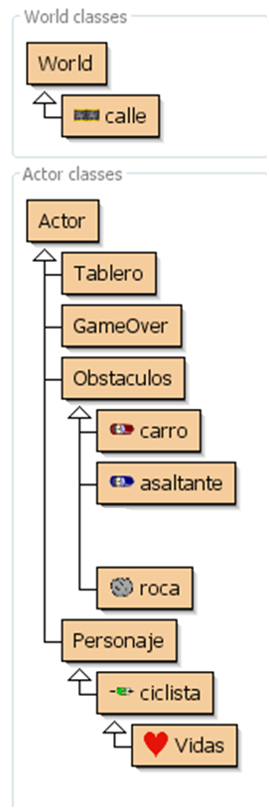

## Class calle

java.lang.Object

greenfoot.World

**calle**

public class **calle**extends greenfoot.World

Esta clase contiene al mundo en general, contiene los metodos para inicializar los actores y mostar puntuacion y vidas

|  |  |
| --- | --- |
| **Field Summary** | |
| Vidas | **life** |

|  |  |
| --- | --- |
| **Constructor Summary** | |
| **calle**()           Constructor for objects of class calle. |  |

|  |  |
| --- | --- |
| **Method Summary** | |
| void | **creaasaltante**(int num)           Este metodo inicializa el actor asaltante |
| void | **creacarro**(int num)           Este metodo inicializa el actor carro |
| void | **crearoca**(int num)           Este metodo inicializa el actor roca |
| void | **prepare**()           prepara el mundo, manda inicializar al jugador, lo coloca en el mundo y manda llamar los metodos para inicializar a los demas actores |

|  |
| --- |
| **Methods inherited from class greenfoot.World** |
| act, addObject, getBackground, getCellSize, getColorAt, getHeight, getObjects, getObjectsAt, getWidth, numberOfObjects, removeObject, removeObjects, repaint, setActOrder, setBackground, setBackground, setPaintOrder, showText, started, stopped |

|  |
| --- |
| **Methods inherited from class java.lang.Object** |
| clone, equals, finalize, getClass, hashCode, notify, notifyAll, toString, wait, wait, wait |

|  |
| --- |
| **Field Detail** |

### life

public Vidas **life**

|  |
| --- |
| **Constructor Detail** |

### calle

public **calle**()

Constructor for objects of class calle.

|  |
| --- |
| **Method Detail** |

### creaasaltante

public void **creaasaltante**(int num)

Este metodo inicializa el actor asaltante

### creacarro

public void **creacarro**(int num)

Este metodo inicializa el actor carro

### crearoca

public void **crearoca**(int num)

Este metodo inicializa el actor roca

### prepare

public void **prepare**()

prepara el mundo, manda inicializar al jugador, lo coloca en el mundo y manda llamar los metodos para inicializar a los demas actores

## Class Tablero

java.lang.Object

greenfoot.Actor

**Tablero**

public class **Tablero**extends greenfoot.Actor

Esta clase diseña todo el tablero que muestra puntos y vidas

|  |  |
| --- | --- |
| **Constructor Summary** | |
| **Tablero**(int c, java.lang.String msj) |  |

|  |  |
| --- | --- |
| **Method Summary** | |
| void | **aumentar**()           Esta funcion aumenta la puntuacion |
| void | **dibuja**()           Esta funcion borra el tablero y despues vuelve a escribirlo con los valores actuales |
| void | **disminuir**()           Esta funcion disminuye las vidas del jugador |
| int | **obtenerValor**()           Esta funcion regresa las vidas para saber si el jugador ya ha perdido o aun no |

|  |
| --- |
| **Methods inherited from class greenfoot.Actor** |
| act, addedToWorld, getImage, getIntersectingObjects, getNeighbours, getObjectsAtOffset, getObjectsInRange, getOneIntersectingObject, getOneObjectAtOffset, getRotation, getWorld, getWorldOfType, getX, getY, intersects, isAtEdge, isTouching, move, removeTouching, setImage, setImage, setLocation, setRotation, turn, turnTowards |

|  |
| --- |
| **Methods inherited from class java.lang.Object** |
| clone, equals, finalize, getClass, hashCode, notify, notifyAll, toString, wait, wait, wait |

|  |
| --- |
| **Constructor Detail** |

### Tablero

public **Tablero**(int c,

java.lang.String msj)

|  |
| --- |
| **Method Detail** |

### aumentar

public void **aumentar**()

Esta funcion aumenta la puntuacion

### dibuja

public void **dibuja**()

Esta funcion borra el tablero y despues vuelve a escribirlo con los valores actuales

### disminuir

public void **disminuir**()

Esta funcion disminuye las vidas del jugador

### obtenerValor

public int **obtenerValor**()

Esta funcion regresa las vidas para saber si el jugador ya ha perdido o aun no

## Class GameOver

java.lang.Object

greenfoot.Actor

**GameOver**

public class **GameOver**extends greenfoot.Actor

Write a description of class GameOver here.

**Version:**

(a version number or a date)

**Author:**

(your name)

|  |  |
| --- | --- |
| **Constructor Summary** | |
| **GameOver**()           Coloca el letrero de juego terminado cuando el jugador pierde |  |

|  |
| --- |
| **Method Summary** |

|  |
| --- |
| **Methods inherited from class greenfoot.Actor** |
| act, addedToWorld, getImage, getIntersectingObjects, getNeighbours, getObjectsAtOffset, getObjectsInRange, getOneIntersectingObject, getOneObjectAtOffset, getRotation, getWorld, getWorldOfType, getX, getY, intersects, isAtEdge, isTouching, move, removeTouching, setImage, setImage, setLocation, setRotation, turn, turnTowards |

|  |
| --- |
| **Methods inherited from class java.lang.Object** |
| clone, equals, finalize, getClass, hashCode, notify, notifyAll, toString, wait, wait, wait |

|  |
| --- |
| **Constructor Detail** |

### GameOver

public **GameOver**()

Coloca el letrero de juego terminado cuando el jugador pierde

## Class Obstaculos

java.lang.Object

greenfoot.Actor

**Obstaculos**

public class **Obstaculos**extends greenfoot.Actor

Write a description of class Obstaculos here.

**Version:**

(a version number or a date)

**Author:**

(your name)

|  |  |
| --- | --- |
| **Constructor Summary** | |
| **Obstaculos**() |  |

|  |  |
| --- | --- |
| **Method Summary** | |
| void | **actasaltante**(int velocidad)           Este metodo inicializa el actor asaltante asigna su velocidad y manda a realizar las acciones correspondientes a un obstaculo |
| void | **actcarro**(int velocidad)           Este metodo inicializa el actor carro asigna su velocidad y manda a realizar las acciones correspondientes a un obstaculo |
| void | **actroca**(int velocidad)           Este metodo inicializa el actor roca asigna su velocidad y manda a realizar las acciones correspondientes a un obstaculo |

|  |
| --- |
| **Methods inherited from class greenfoot.Actor** |
| act, addedToWorld, getImage, getIntersectingObjects, getNeighbours, getObjectsAtOffset, getObjectsInRange, getOneIntersectingObject, getOneObjectAtOffset, getRotation, getWorld, getWorldOfType, getX, getY, intersects, isAtEdge, isTouching, move, removeTouching, setImage, setImage, setLocation, setRotation, turn, turnTowards |

|  |
| --- |
| **Methods inherited from class java.lang.Object** |
| clone, equals, finalize, getClass, hashCode, notify, notifyAll, toString, wait, wait, wait |

|  |
| --- |
| **Constructor Detail** |

### Obstaculos

public **Obstaculos**()

|  |
| --- |
| **Method Detail** |

### actasaltante

public void **actasaltante**(int velocidad)

Este metodo inicializa el actor asaltante asigna su velocidad y manda a realizar las acciones correspondientes a un obstaculo

### actcarro

public void **actcarro**(int velocidad)

Este metodo inicializa el actor carro asigna su velocidad y manda a realizar las acciones correspondientes a un obstaculo

### actroca

public void **actroca**(int velocidad)

Este metodo inicializa el actor roca asigna su velocidad y manda a realizar las acciones correspondientes a un obstaculo

## Class carro

java.lang.Object

greenfoot.Actor

Obstaculos

**carro**

public class **carro**extends Obstaculos

Write a description of class carro here.

**Version:**

(a version number or a date)

**Author:**

(your name)

|  |  |
| --- | --- |
| **Constructor Summary** | |
| **carro**() |  |

|  |  |
| --- | --- |
| **Method Summary** | |
| void | **act**()           Este metodo inicializa el carro heredando las caracteristicas desde la clase Obstaculo |

|  |
| --- |
| **Methods inherited from class Obstaculos** |
| actasaltante, actcarro, actroca |

|  |
| --- |
| **Methods inherited from class greenfoot.Actor** |
| addedToWorld, getImage, getIntersectingObjects, getNeighbours, getObjectsAtOffset, getObjectsInRange, getOneIntersectingObject, getOneObjectAtOffset, getRotation, getWorld, getWorldOfType, getX, getY, intersects, isAtEdge, isTouching, move, removeTouching, setImage, setImage, setLocation, setRotation, turn, turnTowards |

|  |
| --- |
| **Methods inherited from class java.lang.Object** |
| clone, equals, finalize, getClass, hashCode, notify, notifyAll, toString, wait, wait, wait |

|  |
| --- |
| **Constructor Detail** |

### carro

public **carro**()

|  |
| --- |
| **Method Detail** |

### act

public void **act**()

Este metodo inicializa el carro heredando las caracteristicas desde la clase Obstaculo

**Overrides:**

act in class greenfoot.Actor

## Class asaltante

java.lang.Object

greenfoot.Actor

Obstaculos

**asaltante**

public class **asaltante**extends Obstaculos

Write a description of class asaltante here.

**Version:**

(a version number or a date)

**Author:**

(your name)

|  |  |
| --- | --- |
| **Constructor Summary** | |
| **asaltante**() |  |

|  |  |
| --- | --- |
| **Method Summary** | |
| void | **act**()           Este metodo incializa al asaltante por herencia de la clase obstaculo |
| void | **avientabomba**()           Este metodo es heradado por la clase bomba para que el asaltante suelte al azar una bomba contra el jugador |
| int | **creanumero**()           Este metodo inicializa un numero aleatorio para crear la bomba |

|  |
| --- |
| **Methods inherited from class Obstaculos** |
| actasaltante, actcarro, actroca |

|  |
| --- |
| **Methods inherited from class greenfoot.Actor** |
| addedToWorld, getImage, getIntersectingObjects, getNeighbours, getObjectsAtOffset, getObjectsInRange, getOneIntersectingObject, getOneObjectAtOffset, getRotation, getWorld, getWorldOfType, getX, getY, intersects, isAtEdge, isTouching, move, removeTouching, setImage, setImage, setLocation, setRotation, turn, turnTowards |

|  |
| --- |
| **Methods inherited from class java.lang.Object** |
| clone, equals, finalize, getClass, hashCode, notify, notifyAll, toString, wait, wait, wait |

|  |
| --- |
| **Constructor Detail** |

### asaltante

public **asaltante**()

|  |
| --- |
| **Method Detail** |

### act

public void **act**()

Este metodo incializa al asaltante por herencia de la clase obstaculo

**Overrides:**

act in class greenfoot.Actor

### avientabomba

public void **avientabomba**()

Este metodo es heradado por la clase bomba para que el asaltante suelte al azar una bomba contra el jugador

### creanumero

public int **creanumero**()

Este metodo inicializa un numero aleatorio para crear la bomba

## Class bomba

java.lang.Object

greenfoot.Actor

Obstaculos

asaltante

**bomba**

public class **bomba**extends asaltante

Write a description of class bomba here.

**Version:**

(a version number or a date)

**Author:**

(your name)

|  |  |
| --- | --- |
| **Constructor Summary** | |
| **bomba**() |  |

|  |  |
| --- | --- |
| **Method Summary** | |
| void | **act**()           crea una bomba aleatoriamente en el campo para que ataque al jugador |

|  |
| --- |
| **Methods inherited from class asaltante** |
| avientabomba, creanumero |

|  |
| --- |
| **Methods inherited from class Obstaculos** |
| actasaltante, actcarro, actroca |

|  |
| --- |
| **Methods inherited from class greenfoot.Actor** |
| addedToWorld, getImage, getIntersectingObjects, getNeighbours, getObjectsAtOffset, getObjectsInRange, getOneIntersectingObject, getOneObjectAtOffset, getRotation, getWorld, getWorldOfType, getX, getY, intersects, isAtEdge, isTouching, move, removeTouching, setImage, setImage, setLocation, setRotation, turn, turnTowards |

|  |
| --- |
| **Methods inherited from class java.lang.Object** |
| clone, equals, finalize, getClass, hashCode, notify, notifyAll, toString, wait, wait, wait |

|  |
| --- |
| **Constructor Detail** |

### bomba

public **bomba**()

|  |
| --- |
| **Method Detail** |

### act

public void **act**()

crea una bomba aleatoriamente en el campo para que ataque al jugador

**Overrides:**

act in class asaltante

## Class roca

java.lang.Object

greenfoot.Actor

Obstaculos

**roca**

public class **roca**extends Obstaculos

Write a description of class roca here.

**Version:**

(a version number or a date)

**Author:**

(your name)

|  |  |
| --- | --- |
| **Constructor Summary** | |
| **roca**() |  |

|  |  |
| --- | --- |
| **Method Summary** | |
| void | **act**()           Este metodo manda llamar al actor rocaen el mundo por herencia de la clase obstaculo |

|  |
| --- |
| **Methods inherited from class Obstaculos** |
| actasaltante, actcarro, actroca |

|  |
| --- |
| **Methods inherited from class greenfoot.Actor** |
| addedToWorld, getImage, getIntersectingObjects, getNeighbours, getObjectsAtOffset, getObjectsInRange, getOneIntersectingObject, getOneObjectAtOffset, getRotation, getWorld, getWorldOfType, getX, getY, intersects, isAtEdge, isTouching, move, removeTouching, setImage, setImage, setLocation, setRotation, turn, turnTowards |

|  |
| --- |
| **Methods inherited from class java.lang.Object** |
| clone, equals, finalize, getClass, hashCode, notify, notifyAll, toString, wait, wait, wait |

|  |
| --- |
| **Constructor Detail** |

### roca

public **roca**()

|  |
| --- |
| **Method Detail** |

### act

public void **act**()

Este metodo manda llamar al actor rocaen el mundo por herencia de la clase obstaculo

**Overrides:**

act in class greenfoot.Actor

## Class Personaje

java.lang.Object

greenfoot.Actor

**Personaje**

public class **Personaje**extends greenfoot.Actor

Write a description of class Personaje here.

**Version:**

(a version number or a date)

**Author:**

(your name)

|  |  |
| --- | --- |
| **Constructor Summary** | |
| **Personaje**() |  |

|  |  |
| --- | --- |
| **Method Summary** | |
| int | **iniciavidas**() |
| void | **mover**()           Act - do whatever the Personaje wants to do. |

|  |
| --- |
| **Methods inherited from class greenfoot.Actor** |
| act, addedToWorld, getImage, getIntersectingObjects, getNeighbours, getObjectsAtOffset, getObjectsInRange, getOneIntersectingObject, getOneObjectAtOffset, getRotation, getWorld, getWorldOfType, getX, getY, intersects, isAtEdge, isTouching, move, removeTouching, setImage, setImage, setLocation, setRotation, turn, turnTowards |

|  |
| --- |
| **Methods inherited from class java.lang.Object** |
| clone, equals, finalize, getClass, hashCode, notify, notifyAll, toString, wait, wait, wait |

|  |
| --- |
| **Constructor Detail** |

### Personaje

public **Personaje**()

|  |
| --- |
| **Method Detail** |

### iniciavidas

public int **iniciavidas**()

### mover

public void **mover**()

Act - do whatever the Personaje wants to do. This method is called whenever the 'Act' or 'Run' button gets pressed in the environment.

## Class ciclista

java.lang.Object

greenfoot.Actor

Personaje

**ciclista**

public class **ciclista**extends Personaje

Write a description of class ciclista here.

**Version:**

(a version number or a date)

**Author:**

(your name)

|  |  |
| --- | --- |
| **Constructor Summary** | |
| **ciclista**() |  |

|  |  |
| --- | --- |
| **Method Summary** | |
| void | **act**()           Act - do whatever the ciclista wants to do. |

|  |
| --- |
| **Methods inherited from class Personaje** |
| iniciavidas, mover |

|  |
| --- |
| **Methods inherited from class greenfoot.Actor** |
| addedToWorld, getImage, getIntersectingObjects, getNeighbours, getObjectsAtOffset, getObjectsInRange, getOneIntersectingObject, getOneObjectAtOffset, getRotation, getWorld, getWorldOfType, getX, getY, intersects, isAtEdge, isTouching, move, removeTouching, setImage, setImage, setLocation, setRotation, turn, turnTowards |

|  |
| --- |
| **Methods inherited from class java.lang.Object** |
| clone, equals, finalize, getClass, hashCode, notify, notifyAll, toString, wait, wait, wait |

|  |
| --- |
| **Constructor Detail** |

### ciclista

public **ciclista**()

|  |
| --- |
| **Method Detail** |

### act

public void **act**()

Act - do whatever the ciclista wants to do. This method is called whenever the 'Act' or 'Run' button gets pressed in the environment.

**Overrides:**

act in class greenfoot.Actor

## Class Vidas

java.lang.Object

greenfoot.Actor

Personaje

ciclista

**Vidas**

public class **Vidas**extends ciclista

Write a description of class Vidas here.

**Version:**

(a version number or a date)

**Author:**

(your name)

|  |  |
| --- | --- |
| **Constructor Summary** | |
| **Vidas**() |  |

|  |  |
| --- | --- |
| **Method Summary** | |
| void | **disminuir**()           Esta Funcion detiene el juego si el jugador se queda sin vidas |

|  |
| --- |
| **Methods inherited from class ciclista** |
| act |

|  |
| --- |
| **Methods inherited from class Personaje** |
| iniciavidas, mover |

|  |
| --- |
| **Methods inherited from class greenfoot.Actor** |
| addedToWorld, getImage, getIntersectingObjects, getNeighbours, getObjectsAtOffset, getObjectsInRange, getOneIntersectingObject, getOneObjectAtOffset, getRotation, getWorld, getWorldOfType, getX, getY, intersects, isAtEdge, isTouching, move, removeTouching, setImage, setImage, setLocation, setRotation, turn, turnTowards |

|  |
| --- |
| **Methods inherited from class java.lang.Object** |
| clone, equals, finalize, getClass, hashCode, notify, notifyAll, toString, wait, wait, wait |

|  |
| --- |
| **Constructor Detail** |

### Vidas

public **Vidas**()

|  |
| --- |
| **Method Detail** |

### disminuir

public void **disminuir**()

Esta Funcion detiene el juego si el jugador se queda sin vidas